Holy Week and Easter 2020
We live in challenging times and most of us have never been in a situation where Holy Week and Easter can’t happen in our Church building. However, this doesn’t mean that we can’t still pray and share in the different liturgies of Holy Week and Easter and live out the story of Jesus.
This Holy Week we are inviting you to help create content for our worship from Palm Sunday through Maundy Thursday, Good Friday and Easter Sunday.
We’re looking for lots of creativity from all of you, adults and children. Make, design, paint, draw or write a poem; make short videos; anything to inspire us in worship so that we can add them to our webpage.
Videos should be between 10 and 90 seconds, taken on your phone in landscape mode. Please make sure children’s faces cannot be seen and that you have permission from the people filmed to be published online, otherwise we will be unable to use the videos. When you email, please add your names and the names of everyone else who helped create or star in your video.

Here are some ideas!
Palm Sunday
Let’s see if you have been able to make a paper palm cross or decorate your hand, or maybe have found some green leaves to put in your window or on your front door
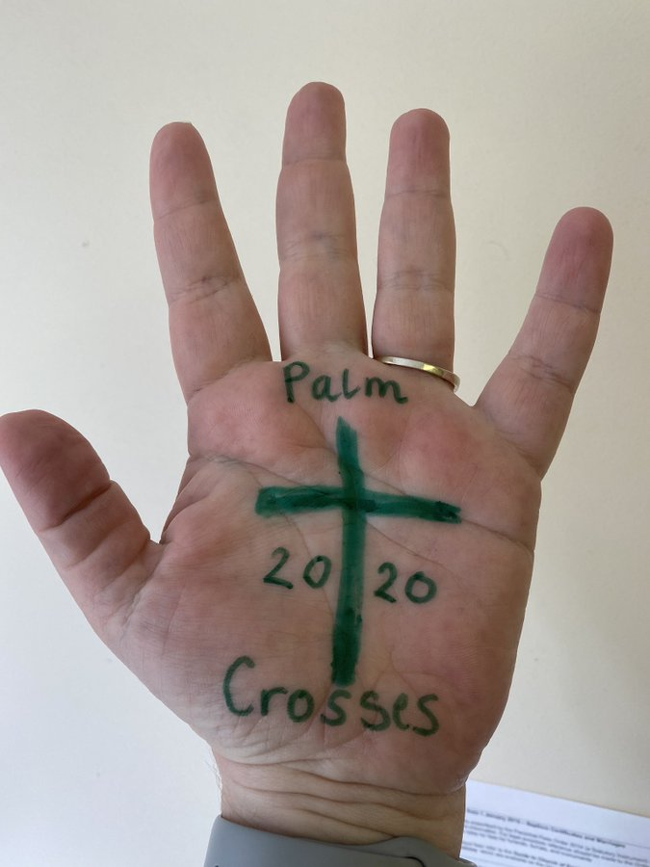

Maundy Thursday
Washing hands or feet as Jesus did for his disciples.
Remembering the Last Supper Jesus shared with his disciples

Good Friday
Remembering Jesus suffering and dying for us on the cross
“What the Cross of Jesus means to me”

Easter Sunday
Jesus is raised from the dead !
“ What living the Jesus way means to me “

When you follow one of our services you may ﬁnd it helpful to have a cross of some sort and a candle as a visual focus. You might like the challenge of making a cross out of whatever materials you have to hand.
Bible readings can be found on www.biblegateway.com
Or http://www.bible.is/ a Bible website where you can also hear and see as well as read
Above all, know and trust that we do not pray alone or in spiritual isolation. We join our prayers with Christians around the world and with the whole company of heaven as we worship and adore God.
May God Bless each of us this Holy Week.

