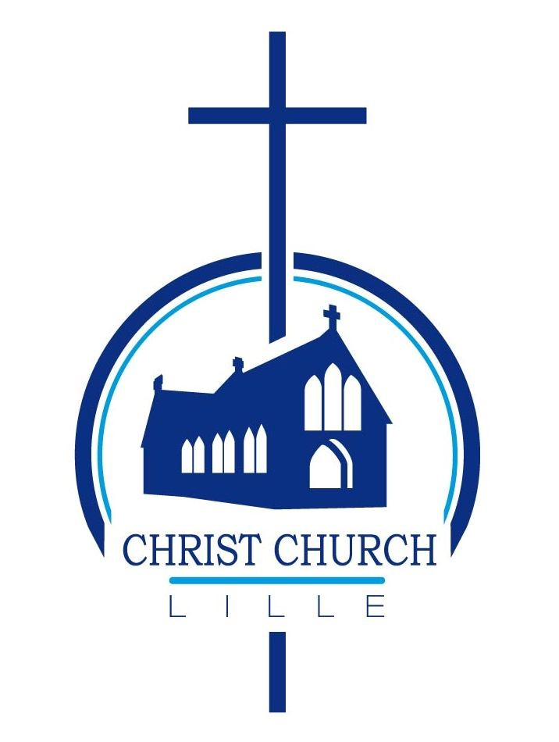
CHRIST CHURCH LILLE

CANDIDATE FOR CHURCH COUNCIL

I the undersigned wish to stand for election as a member of the Church Council at Christ Church Lille.
- I am on the Electoral Roll of Christ Church Lille.
- I am aware of the need for Safeguarding awareness and DBS* checks
- If elected, I will complete the required level of Safeguarding training** for this role

NAME | SIGNATURE
DATE

Proposer and Seconder must also be on the Electoral Roll

Proposed by:

NAME | SIGNATURE
DATE

Seconded by:

NAME | SIGNATURE
DATE

* DBS stands for Disclosure and Barring Service; it means that for some roles, criminal records need to be checked.

** The Safeguarding Officer will inform you of the training level you need to complete, all training is online.

