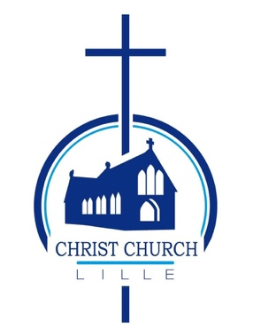
NOTICE OF REVISION OF CHURCH ELECTORAL ROLL

Diocese of Europe,
Chaplaincy of CHRIST CHURCH LILLE

Notice is given that the Church Electoral Roll of Christ Church Lille will be revised by the Church Council, beginning on 1 March 2022 and ending on 3 April 2022.

After the revision, a copy of the Roll will be published by the Church Council and shown in the church from 10 April 2022 and a copy of the Roll will be available for inspection on a reasonable request being made to the Council.

Details of lay people entitled to have their name entered on the roll is shown in the document on the noticeboard, and also on the Electoral Roll Application Form. This is available on the website and copies are available at the back of the church.

For enquiries, please contact

electoralroll@christchurchlille.fr

Date: 13 February 2022

