Re-purpose your tin cans

Fresh fruit and vegetables are great, but tinned food is a brilliant stand-by. Full of vitamins and minerals, it keeps for ages, and as a bonus, you can recycle the tins!

- Remove the lids carefully, making sure there are no sharp edges; file if necessary
- Remove the label and wash (in the dishwasher if possible)

Large 450g size tins

- Make wonderful planters for seeds and bulbs. With a nail and a hammer, pierce a few holes in the bottom before filling with earth/potting compost and away you go!
- Make a children’s game for the garden: stack tins in a pyramid and try to knock them down with beanbags or tennis balls. Scoring rules are up to you

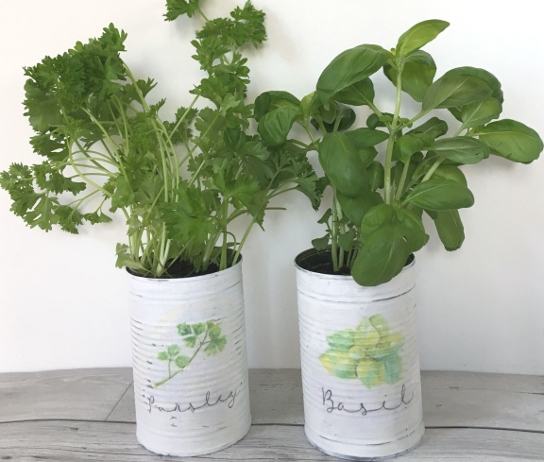
Smaller 250g size tins

- They make great candle holders
- Pencil pots, storage pots
- Decorate and use as flower vases
- Grow herbs such as basil or parsley

Lots more ideas online:
https://sustainmycrafthabit.com/upcycled-tin-can-crafts/
