Re-grow your vegetables

Did you know you can regrow some lettuces, spring onions and celery from the root ends? And grow delicious leaves from carrot tops?

Romaine lettuce (cos)
(It works with other lettuces, but romaine is best here)

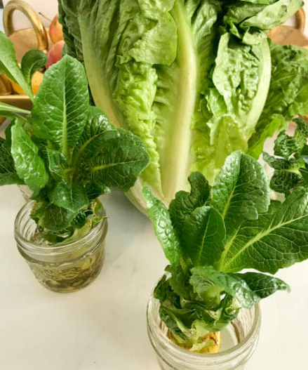
You won’t get a full lettuce, but enough leaves for a sandwich. Here’s how:

- Cut the bottom off the lettuce (about an inch or 3 cms)
- Place this in a shallow dish with water (about half-way up)
- Place on a window sill
- Change the water every 1 – 2 days
- Watch it grow!

After 10 days you’ll have enough leaves for a sandwich. Don’t leave it any longer, it will be bitter.
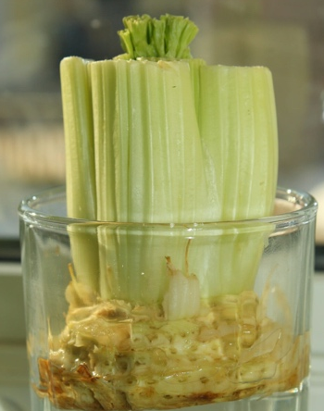
Celery stalks

In a similar way, put the root you cut from the stalks into water and wait.
You won’t get nice white stalks, but the green leaves are excellent for flavouring.

Green onions

Cut the onions so there is about an inch of white root remaining. Put into water in the usual way and watch them grow.

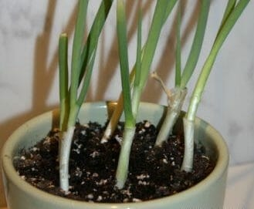
You can transplant them into a pot of earth for full sized onions when they are big enough.
If they have roots when you buy them, you can eat the tops and plant the roots directly into soil.

Carrot tops

You can’t grow carrots, they need deep earth, but the leaves are pretty and can be used for cooking or flavouring.

Websites:
https://www.mystayathomeadventures.com/
https://www.gettystewart.com/category/gardening-2/fun-ideas/
(photo credits from these websites)

(NB some websites refer to US gardening, but pineapples and avocados won’t produce fruit here, sorry!)

