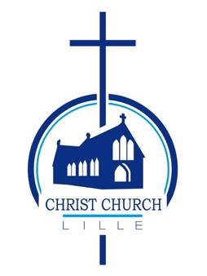
CHRIST CHURCH LILLE
THE ELECTORAL ROLL

Under the Church Representation Rules, a lay person is entitled to have his or her name entered on the roll if the person –
(a) is baptised,
(b) is aged 16 or over, and
(c) has made one of the following three declarations and duly applied for enrolment.
- The first declaration is that the person is a member of the Church of England or of a Church in communion with it and is resident in the parish.
- The second declaration is that the person is a member of the Church of England or of a Church in communion with it, is not resident in the parish, but has habitually attended public worship in the parish during the preceding six months.
- The third declaration is that the person is a member in good standing of a Church which is not in communion with the Church of England but subscribes to the doctrine of the Holy Trinity and is also a member of the Church of England and has habitually attended public worship in the parish during the preceding six months.

Application Forms for enrolment can be obtained from the Church Electoral Roll Officer or on our website. In order for a person to be entitled to attend the annual parochial church meeting and to take part in its proceedings, an Application Form for enrolment must be returned by 28 March 2023 for the ending of the revision of the Church Electoral Roll by the Parochial Church Council.

Any error discovered in the Roll should at once be reported to the Church Electoral Roll Officer.

electoralroll@christchurchlille.fr
https://christchurchlille.fr/resources/

12 February 2023

