Jesus said to her, “I am the resurrection and the life.
The one who believes in me will live, even though they die… John 11.25

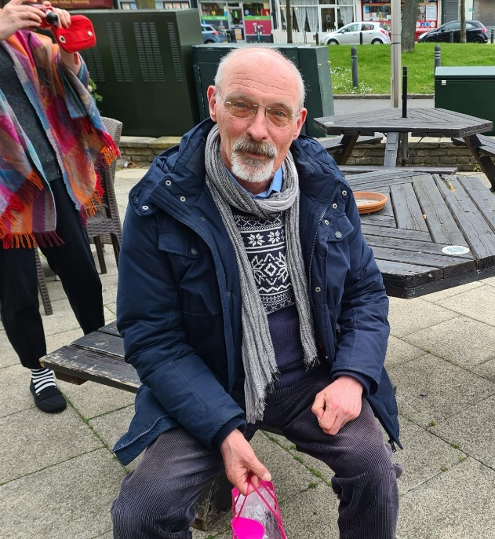

MARtin braY
19 march 1959 – 28 aPril 2023

The funeral will take place on
Friday 5 May at 2.30pm
at
Christ Church, Lille
14 rue Lydéric, 59800 Lille
followed by the burial at Mons-en-Baroeul cemetery
(2 rue Jean Jaurès, Villeneuve d’Ascq)

Please do not bring flowers.
If you would like to make a gift in memory of Martin, donations will be divided between Tear Fund, the French Protestant Church in Lille-Fives and the Lille Anglican Solidarity Fund.

