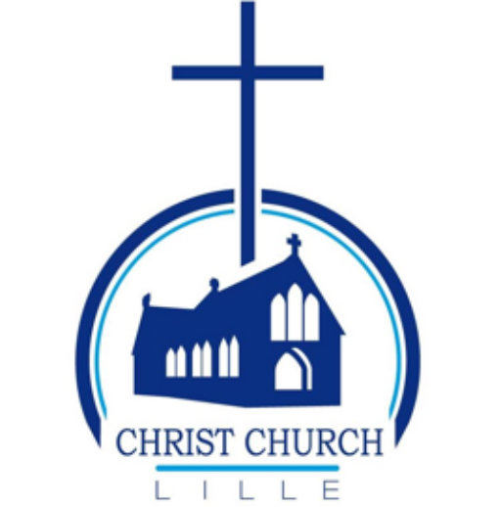
CHRIST CHURCH LILLE
AGM APRIL 2026
REPORTS on 2025

I CHURCH LIFE
- Vice-chair’s report
- Small groups
  - Ladies’ Bible Study
  - Working with Christ
  - Sunday Club
- Safeguarding
- Outreach

II CHURCH BUILDINGS
- Church fabric report
- Building report
- Eco church

III THE WIDER CHURCH FAMILY
- Archdeaconry
- Diocese



I CHURCH LIFE

An Overview report on 2025 by our Lay Vice-chairman
In the interregnum, without a chaplain, it is our lay vice-chair who leads the church council

This has been a year shaped by interregnum. As Lay Vice-Chair, I have served as President of the Church Council, and I am grateful to every member, volunteer and worshipper who has kept Christ Church Lille alive and in good heart throughout.
Search for a New Chaplain
The chaplaincy search has been our central challenge. After advertising the post, twelve information packs were sent out but only two candidates came forward. Sadly neither was a suitable fit. Both the Archdeacon, Peter Hooper, and the Director of the ICS have supported us closely throughout.
The options now before us include re-advertising the half-stipend post (already reposted on the ICS website), a House for Duty arrangement, or exploring whether a full-time chaplain could be funded. These discussions will continue with the new Council after the AGM.
For 2026, We are very pleased to welcome the Reverend Canon Dr Gary Wilton as locum chaplain from 5 July to 30 August. And we owe an enormous debt of gratitude to the Reverend Elisabeth Dean, who led our Holy Communion services with such faithfulness and generosity during the interregnum. As she steps back from regular visits over the summer, we thank her from the bottom of our hearts. Our Congregational Worship Leaders have also been invaluable in leading Morning Prayer each first Sunday.
Buildings
The church, hall and chaplaincy house have all been well maintained. Key works include: a new water supply; new windows and door at the chaplaincy house; a security alarm following an attempted break-in; and the completion of roof works at the back kitchen, which is already warmer. A new projector and IT upgrades have also been completed.
Finances
The 2025 accounts show a surplus of €12,256, with reserves of €38,288 at year end. The 2026 budget, approved by Council, sets income at €50,000 and expenditure at €40,000, based on continuing in vacancy. We remain grateful to our generous donors, while being mindful of the need to diversify our income base for the longer term.
Safeguarding
Safeguarding remains a priority. We thank Maggie Devos for her continuing work as Assistant Safeguarding Officer. Clearances for Sunday Club helpers are being progressed. Once in place, Sunday Club can resume. We must be ready for the Diocesan audit in 2027.
Other Matters
Claire Nevin is engaging with us as prospective Local Environment Officer, exploring the A. Rocha and Eden Project Award Scheme. An International Evening is planned for the autumn to welcome new students. The Council has also approved migration to a new accounting platform, Theo-Asso.
Thanks
My sincere thanks to: the Churchwardens David Bolton and Calvin Devanesan; our Secretary Rosemary Ulyett; Treasurer Tony Banton; Maggie Devos for safeguarding, service preparation and so much more; Nathan Hepler for managing our sound and AV so diligently; Martha Hepler for leading our music; our Congregational Worship Leaders; and every member and volunteer who makes this community what it is.

Daniel Ross
Lay Vice-Chair, Christ Church Lille, April 2026

Reports from our small groups

Ladies’ Bible Study
Over the past year, the Ladies’ Bible Study at Christ Church Lille has remained a special place for connection, encouragement, and spiritual growth. Gathering weekly during term time, a friendly group of six to eight women meets in the church hall to explore God’s Word together. One highlight was our much-loved Hidden Heroes series, which brought to life the stories of those who played significant roles in God’s greater plan yet are often easily overlooked. We also revisited familiar passages, discovering fresh meaning and insight through rich and thoughtful discussion.
And, of course, no gathering would be complete without a cup of tea or coffee, enjoyed in an atmosphere of warmth, friendship, and mutual support. We are thankful for all that God has been doing among us and look ahead with anticipation to the coming year, always ready to welcome new faces to join us.
For further information contact Maggie - womensgroup@christchurchlille.fr

Working with Christ

The group continues to meet approximately monthly in the church hall, where they enjoy coffee, croissants and the opportunity to share experiences and working practices for Christians at work.
Contact david.bolton@christchurchlille.fr



Sunday Club

Sunday Club met on two occasions during the year, in September and October 2025. We are grateful to all those who helped on those Sundays.
As reported to the Church Council, Sunday Club cannot operate on a regular basis until the required safeguarding clearances are in place. Our current focus is therefore on ensuring that at least two people obtain the necessary clearances and complete the required Basic and Foundational safeguarding training. Once this is done, we look forward to re-establishing Sunday Club as a regular and valued part of our Sunday morning worship.
We hope to be in a position to offer this again to our families and children in the not too distant future, and would welcome expressions of interest from anyone willing to help.
Daniel - sundayclub@christchurchlille.fr

Safeguarding

Over the past year, safeguarding at Christ Church Lille has remained a central part of our ministry, and we are thankful to report that there have been no safeguarding concerns raised. This reflects the ongoing care, awareness, and commitment of our volunteers and leaders, who continue to play a vital role in maintaining a safe and welcoming environment for all.
We currently do not have a Safeguarding Officer, as Tom Boon relocated to Paris for work at the end of last year. In the interim, safeguarding responsibilities are being supported by our Assistant Safeguarding Officer as we work towards appointing a new Safeguarding Officer in due course.
Looking ahead, with an External Audit scheduled for 2027, it is especially important that all group leaders and volunteers ensure their safeguarding training remains up to date. The Church of England’s online safeguarding training continues to be available to everyone, and we strongly encourage participation to help us uphold best practice across all areas of church life.
The CCL Safeguarding Team will continue to keep the PCC informed and engaged as we work together to ensure the ongoing safety and wellbeing of our community.
Maggie Devos
Assistant Safeguarding Officer

Outreach

Using our church building in the service of others
- We offer the use of our church premises to two other Christian churches, who meet regularly here as they do not have their own church building.
- We are glad to offer the use of our store-room to a homeless charity; they store items they can distribute around Lille in their support for the homeless.

La Solidarité Anglicane de Lille
This is out outreach association, set up specifically to donate to charities and organisations. For a full report on their activities, see the recent AGM report at https://christchurchlille.fr/what-we-do/outreach/
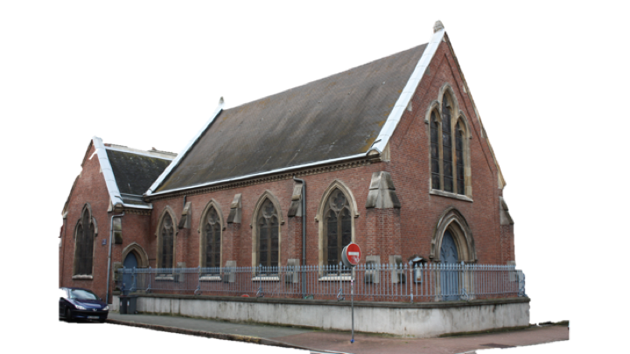
As far as funds permit, we aim to donate 10% of the total income of CCL and La Soli to those n need.

II CHURCH BUILDINGS

Churchwarden’s report
There is no change to the inventory of church property.
As you may know, the church building belongs to the town hall. The people we work with at the town hall have been extremely helpful, and we are very thankful. We are still waiting to get a timeline for when work on our roof, the lighting, the toilet area, as well as installing disabled access will happen.
We continue to monitor the electricity and gas consumption of the heating system. We keep gas consumption as low as possible. But that means a small team of members has to coordinate to come in to turn the system on and off, for our activities but also those of the churches using the church and hall.
A few members have also been very active making sure that the church and hall are cleaned and tidied, and the bins taken out and brought back in. We are very grateful for the time and effort of those involved.
We do of course monitor any needs for repairs to the chaplaincy house. Some repairs were carried out this year, including changing doors and windows, installing a burglar alarm and a few minor refurbishments. The works planned were also carried out on the roof (early 2026).
We can’t end without thanking the many volunteers who help all through the year, often in the shadows, keeping the church and house well maintained, cleaned, those who deal with all the administrative work linked to running several buildings. Their work for the church is noticed and greatly appreciated.

David Bolton, Churchwarden

Buildings report

Chaplaincy house
- replacement door and windows fitted, reducing heat loss
- one attempt at forced entry, burglar alarm now fitted, working efficiently
- problem with shower door still to be resolved, intermediate solution (shower curtain) provided.
- minor refurbishment carried out, waiting for new incumbent before further changes
- lamp on timer fitted to indicate occupancy
- some improvements needed to lighting ie LED lamps

Plans for 2026 (in fact now completed)
- replacement roof over bathroom, which was leaking
- adjustment to tiled roof over back kitchen, which was causing damp

Church building
- still waiting for news of disabled access works, but these are major and depend on TH budget allocations
- TH is aware of the problems with the lighting, they have asked for a quote but again, depends on budget allocations
- heating remains an issue: the system was set up in pre-Covid times, and is not suitable for present use. It is an excellent system but we can’t afford to run it. Currently depending on a few members to turn on and off and this is becoming an issue. Infra-red heaters or under-pew heaters in the church would be a good solution, but would need major financial input; these could be controlled remotely.
- increasing use by Pentecostal church, and some complaints about noise from neighbours; they have been made aware of issues with storage of their effects, and also about eating in the church
- major cleaning efforts much appreciated; however, the outside of the church is not very tidy. Also, since Anthony not available, we are reliant on other helpers to put out and take in the bins
Rosemary Ulyett

III THE WIDER CHURCH FAMILY

Archdeaconry

Growing Together
Across the Archdeaconry, chaplaincies have been getting to know each other better — sharing ideas, offering support, and stepping in to help where needed. New networks are taking shape around Safeguarding, Eco-church, and Treasurers, giving people with shared responsibilities a space to connect. And after some years where communication felt patchy, it’s genuinely improved — both between chaplaincies and with the Diocese
Keeping in Touch
Synodical meetings are still held on Zoom, and that’s unlikely to change soon — getting people together in person across such a large area is simply too costly. But there’s a real upside: Zoom has brought in voices that would never have been heard otherwise. People who couldn’t travel, or who live far from the usual meeting points, are now part of the conversation. That feels like genuine progress.

A Moment Worth Mentioning
One lovely highlight: in May, chaplaincies across the Archdeaconry came together to create a congratulatory video for the Archdeacon’s marriage. It was a small gesture, but it said a lot about the warmth and spirit that’s been growing across this community.

What’s Next
The hope for the year ahead is simply to keep building on what’s working — nurturing the new networks, staying connected through whatever means work best, and continuing to grow the sense that, however spread out we are, we’re in this together.
Archdeaconry Synod representatives Rosemary Ulyett and Maggie Devos



Diocese

The 2025 Diocesan Synod brought together clergy and lay representatives from across the European Diocese to consider the Church’s mission and future priorities.
Key themes included parish sustainability, community outreach, and closer collaboration between churches.
One particularly interesting contribution was the progress report on the Children and Young People Strategy, presented by Rev Ian Bendrey, highlighting ongoing efforts to better engage younger generations in the life of the Church.
It was also a valuable opportunity to connect with others from across the Diocese, strengthening relationships and sharing experiences from different church contexts.
Overall, the Synod provided a helpful space for discussion and a reminder of the importance of continuing to respond to the challenges facing the Church today.

Maggie Devos, Diocesan Synod Rep

