Trace the words below:
Words to remember
Jesus Jésus
Share Partager
Bread Pain
Thanks Merci
Enough Assez

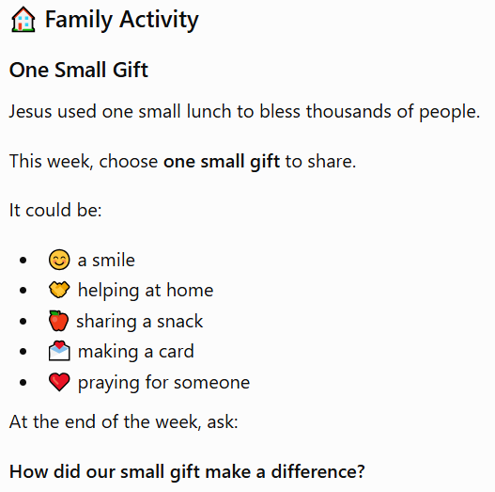

Welcome / Bienvenue
Children’s activity sheet (3-11yrs)

Jesus Feeds Everyone
Jésus nourrit tout le monde

CHRIST CHURCH, LILLE – International English-Speaking Church
Jesus Feeds Everyone (Matthew 14:13-21)
Have you ever shared your lunch or a snack with someone?
Sharing can make a big difference.
One day, Jesus and his disciples went to a quiet place to rest. But a large crowd of people followed them. They wanted to hear Jesus teach and see him heal those who were sick.
As the day came to an end, everyone was hungry.
The disciples said, "Send the people away so they can buy some food."
But Jesus said, "You give them something to eat."
The disciples only had five loaves of bread and two fish. It didn't seem enough for such a big crowd.
Jesus thanked God for the food. Then he shared it with everyone.
Something amazing happened!
Everyone had enough to eat, and there were twelve baskets of leftovers.
Jesus showed that when we trust him, he can do wonderful things.
The good news is simple: With Jesus, there is always enough to share.

Let Us Pray
Dear Jesus,
Thank you for taking our small gifts and using them in amazing ways.
Help us to share what we have with joyful hearts and to trust you each day.
Amen.



Share what you have

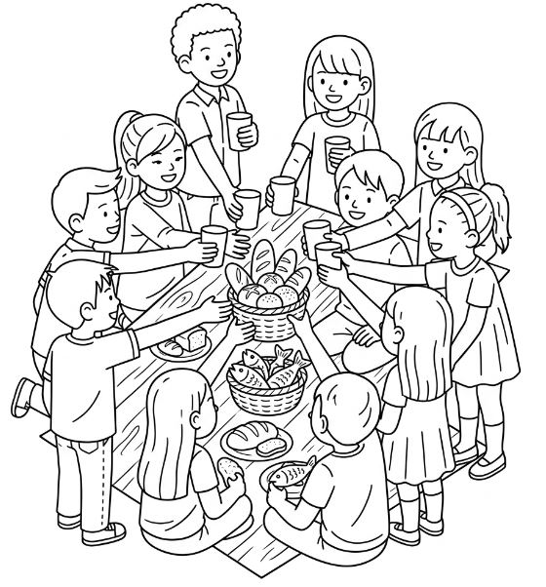
Jesus can use small gifts to do great things

This Picture was coloured in by: (Write your name below)

____________________________________________________________

